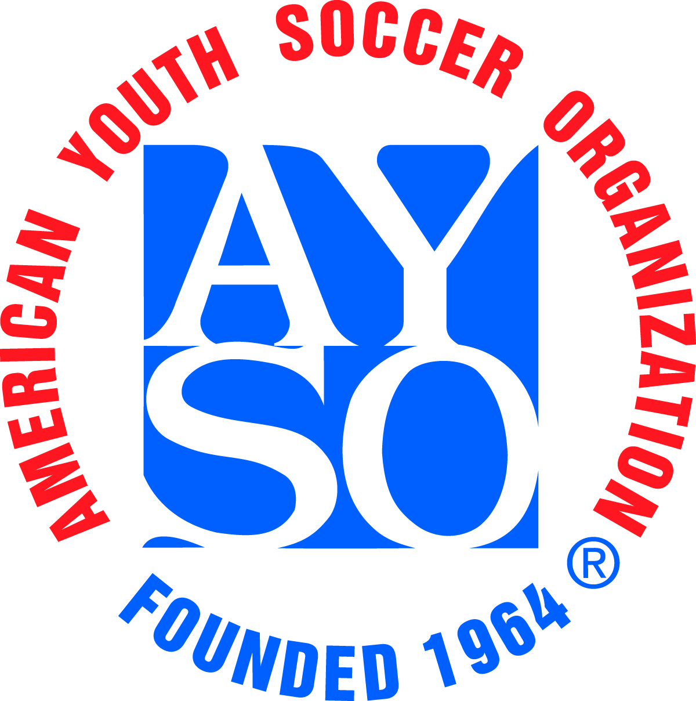 | AYSO Chino Turkey  Tournament | 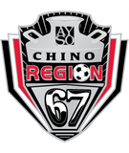

Scope: | AYSO Invitational – open to AYSO teams only from all Sections.
When: | Fri- Sunday Nov 24-26 2024 – Rain out dates –None
Where: | The tournament will be held at Ayala Park in Chino. There is no charge for parking. No pets are allowed at fields.
Who: | AYSO boys and girls teams in age divisions: U-14 (11v11) 15 players max. U-12 (9v9) 12 players max. and U-10 (7v7) 10 players max. All players must be registered to and have played in the AYSO Fall 2023 primary season. Guest players will be allowed (3 maximum per team). No Co-ed teams will be accepted to this tournament.
What: | Pool play tournament. Each team will be guaranteed 3 games in pool play. The top teams will advance to the medal round on Sunday Afternoon
Why: | The Chino Turkey Tournament is being conducted as a fundraiser by Region 67 to raise funds for Field Development, Equipment, & Maintenance, and to provide Scholarship funds for youths in Region 67.
Awards: | All players and 2 coaches per team will receive a tournament t-shirt and pin. All players on the 1st, 2nd, 3rd, & 4th place teams will receive a medal and a Coaches trophy will be awarded for 1st Place.
Entry Fee, Refunds: | $600 for U-14, $550 for U-12, and $525 for U-10. A full refund will be issued if tournament is canceled and cannot be rescheduled. If a team withdraws 30 or more days before the tournament, a full refund is given. Within 30 days of the tournament, no refund is provided unless a replacement team is found.
Referee Fee, Refunds: | $250, refundable within 14 days of the tournament, if referee assignments have been completed. Each team is asked to provide a qualified 3-person referee team to cover 3 games during the tournament. Partial refunds will be given based upon the number of game slots completed.
Rules: | A full set of tournament rules are posted on the tournament website.
Acceptance: | The application deadline is Nov 1st , 2023. All teams will be notified within 48 hrs. of the application deadline or receipt of application (whichever is latest) as to their status. Teams that are not accepted will be given the option to have their complete application returned or to be placed on the waiting list (see rules).
How: | Team entry applications and all necessary forms are available on the tournament website.  Please send 1 Region check that covers both the Entry and Referee fees, along with the tournament application, referee information form, and team roster to the Tournament Registrar address below. Regional commissioner must sign application and team roster. Appropriate referee administrator must sign referee information form. See referee form for details.  Make region check payable to: AYSO Region 67
Address: | AYSO Region 67 Chino Turkey Tournament Information: Call: John Cardenas (909) 313-9354  Registrar E-Mail: Chinomilkcan@gmail.com  P.O. Box 861 Website: www.ayso67.org  Chino, California, 91710

